**ID: bvarshsp**

**Name: Varsha SP**

**Day 3 – 21th May 2025**

**Task 1:**

Recap of Last session:

Create a file names 21st May.txt and push it to your git hub.

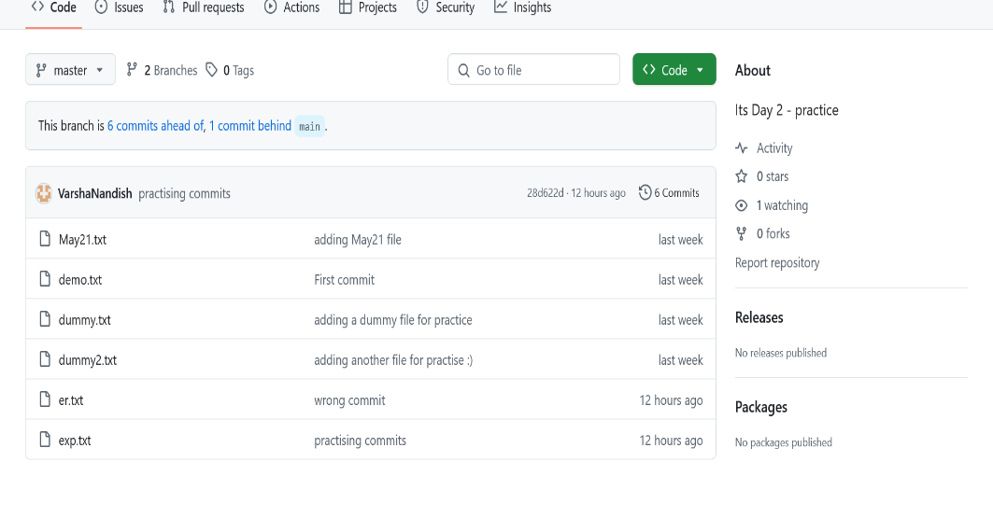

**Task 2:**

ACID definitions:

**1. Atomicity: "All or Nothing"**

**Atomicity ensures that a transaction is atomic, it means that either the entire transaction completes fully or doesn't execute at all. There is no in-between state i.e., transactions do not occur partially.**

**2. Consistency: Maintaining Valid Data States**

Consistency ensures that a database remains in a valid state before and after a transaction. It guarantees that any transaction will take the database from one consistent state to another, maintaining the rules and constraints defined for the data. In simple terms, a transaction should only take the database from one **valid** state to another.

### 3. Isolation: Ensuring Concurrent Transactions Don't Interfere

This property ensures that **multiple transactions** can occur concurrently without leading to the **inconsistency** of the database state. Transactions occur independently without interference.

### 4. Durability: Persisting Changes

This property ensures that once the transaction has completed execution, the updates and modifications to the database are stored in and written to disk and they persist even if a system failure occurs. These updates now become permanent and are stored in **non-volatile memory**.

RDBMS Doc 4.pdf

<https://drive.google.com/file/d/1cgSZ6wmPmFbx-tC78lt6zC9UBYiDJlyP/view?usp=sharing>

NOSQL Doc 5 pdf

<https://drive.google.com/file/d/1PDqGKE766Z-rG4GVh3ycwJyrraiJV-my/view?usp=sharing>